**Crisis Committee:**

**The Bosnian War/Genocide, 1992-1995**

*“The tragedy of Srebrenica will forever haunt the history of the United Nations.”*

* Kofi Annan, Secretary General of the United Nations, July 2000[1]

Widely recognized as the worst act of violence and the only instance of genocide in Europe since the end of WWII, the massacre at Srebrenica resulted in the deaths of over 8,000 Muslim Bosnian boys and men in July 1995. In less than one week, the Bosnian Serb Army captured the town of Srebrenica, assured its inhabitants that no one would be harmed, and then systematically separated, tortured, and executed its population. The tragedy of Srebrenica was shocking – shocking in the magnitude of crimes committed and shocking in the incredible failure of the United Nations Security Council, the UN Peacekeepers, and NATO to ensure the safety of a vulnerable population in a declared “safe area.”

Could this tragedy have been prevented by different action on the part of the United Nations, its Dutch peacekeeping forces, and NATO? Almost certainly. What follows details key points of inflection in the lead up to the massacre where different decision-making could have changed the outcomes of the countless lives lost and forever altered.

**The Bosnian War**

The Bosnian War began with the breakup of Yugoslavia in 1990 at the end of the Cold War. Yugoslavia was a multicultural state formed at the end of WWI, which became a communist nation after WWII and comprised of six republics and two autonomous areas. When interest rates rose in the late 1970s (due to a shock in oil prices stemming from the Yom-Kippur War and the Iranian Revolution), Yugoslavia found itself struggling to maintain consumer spending, subject to high debt interest payments, and incapable of borrowing from private banks. As part of the terms of a structural adjustment agreement, the International Monetary Fund (IMF) imposed fiscal austerity measures on the country. But the Yugoslav republics continued to print money and set their own interest rates, leading to hyper-inflation and high unemployment. As the federal government lost its ability to govern the republics as one entity, ethnic nationalism surged in each republic and the state of Yugoslavia began to unravel. Of course, this did not happen in isolation. Across this same period, the Berlin Wall fell, communism in Eastern Europe collapsed, and by 1991, the Soviet Union itself had fallen apart.

Historically, Bosnia had been a multi-ethnic state as a province of the Ottoman empire. In 1991, 44% of the population identified as Muslim (Bosniak), 33% as Serb, 17% as Croat, and 6% as Yugoslav.[2] The population was relatively secular as well (see left-hand demographic map in Image 1 on the following page). As Yugoslavia disintegrated, so too did the national media. In its place rose ethnic media (Serb media, Croat media, etc.) that set the stage for the militias that later sought to establish enclaves through ethnic cleansing.

Croatia and Serbia declared independence first in 1991, followed by Macedonia and Bosnia- Herzegovina in 1992. The United States and the European Economic Community recognized Bosnia as an independent state in April 1992. Bosnian Serbs, who boycotted the independence referendum and desired to remain a part of Yugoslavia, established a separate entity called Republika Srpska (also known as the Bosnian Serb Army or BSA) within Bosnia. The President of Serbia, Slobodan Milosevic, recognized this group and triggered the war. Milosevic, who aimed to create a new Serbian nation, launched an offensive with the Serb-dominated former Yugoslav army in support of Republika Srpska. They began their attack on the capital city of Sarajevo shortly thereafter.

**Image 1: The Breakup of Yugoslavia**

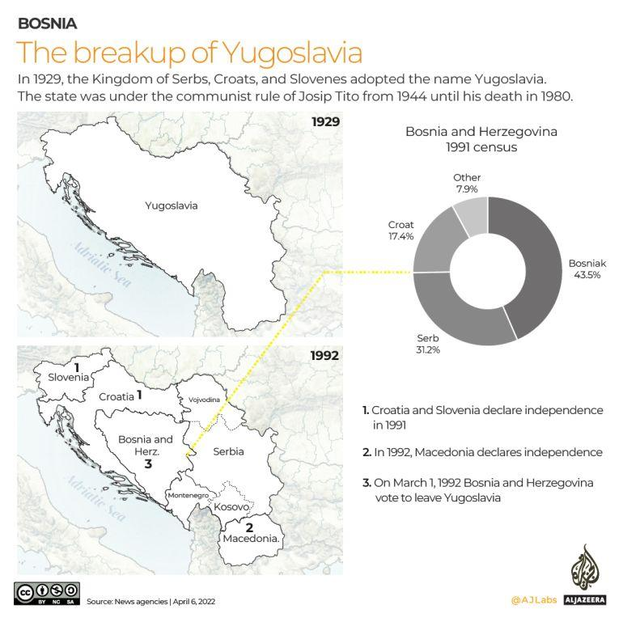

Source: Aljazeera. [*30 years since the Bosnian War*](https://www.aljazeera.com/news/2022/4/6/infographic-30-years-since-the-bosnia-war-interactive.)*.*

The Bosnian War lasted from 1992-95. In her book *New and Old Wars,* British academic Mary Kaldor posits that the Bosnian War was actually a full-fledged civil war, rather than the local ethnic conflict that most observers and policy makers incorrectly assessed at the time, leading to international indifference in the face of the gathering catastrophe. The war in Bosnia was waged by ethnic militias – often resembling criminal groups rather than armies – against civilian populations in regions that these militias sought to control. It was essentially war of Serbian militias against Bosnian civilians designed to depopulate the Muslim ethnic group, an attack that some have labeled “genocide,” or ethnic cleansing. Before the war, for example, there were nearly 350,000 Muslims living in Northern Bosnia. After the war, only 13,000 remained. Such ethnic-targeted warfare on the civilian population followed a horrifying routine:

*“The typical pattern applied to rural areas – villages and small towns. First, the regular forces would shell the area and issue frightening propaganda so as to instill a mood of panic. . . . Then the paramilitary forces would close in and terrorize the non-Serb residents with random killing, rape and looting. Control over local administration would then be established. In the more extreme cases, non-Serb men were separated from the women and killed or taken to detention centers. Women were robbed and/or raped and allowed to go or taken to special rape detention centers. Houses and cultural buildings, such as mosques were looted, burned and blown up”[3]*

The high point of the war came in March 1995 when BSA President Karazdic issued Directive 7. Directive 7 marked an extreme escalation in violence, calling for the BSA to “create an unbearable situation of total insecurity with no hope of further survival or life for the inhabitants of Srebrenica and Zepa [two UN safe areas].”[4] The violence Directive 7 called for culminated in the Srebrenica massacre in July 1995. After the mass atrocities in Srebrenica, later called the West’s “greatest shame,” the U.S. and its allies finally took direct action. NATO conducted a comprehensive air campaign against BSA targets which, coupled with intense diplomatic negotiations, led to the Dayton Peace Accords in November 1995. This agreement brought an end to the conflict, establishing a framework for peace in war-ravaged Bosnia-Herzegovina.[5] But this was a peace that ended the war on lines the BSA might have designed, for ethnic cleansing completely changed the demographic map of Bosnia into a series of ethnic enclaves very different from the multicultural topography of 1991 (see Image 2).

**Image 2: The Ethnic Distribution of Bosnia Before and After the War**

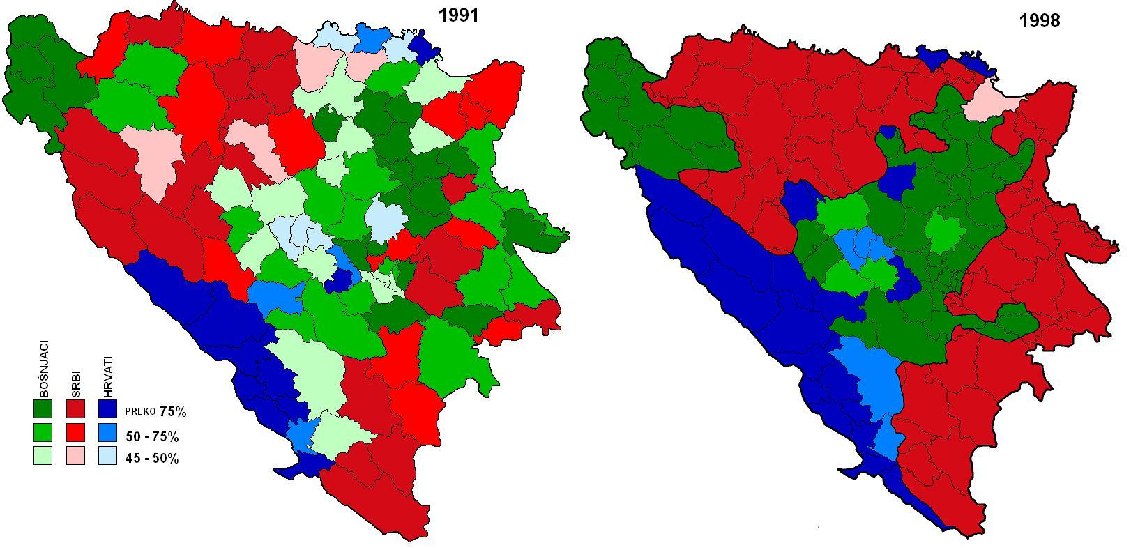

Key: red areas are Serb; blue areas are Croat; green areas are Bosnian. Color shading intensifies as the percent of population represented by each group increases.

Source: Kaldor, Mary. *New and Old Wars.*

**The Srebrenica Massacre**

The ways in which the international community failed Bosnia are numerous. One of the most egregious failures was in the lead up and follow through of the BSAs plan to execute thousands of refugees inhabiting Srebrenica. The table below follows that sequence of events.

**Table 1: Timeline of Events Leading to the Srebrenica Massacre and Cover Up**

|  |  |
| --- | --- |
| **Rising Tensions** | |
| 1991 | * The United Nations Security Council adopts Resolution 713, imposing an arms embargo on all parties to the conflict (the Bosnian War). This was later expanded to include a NATO enforced no-fly zone over Bosnia and Herzegovina in 1992. * The embargo was intended to lessen the fighting, but the actual effect was to lock in the Bosnian Serb Army’s (BSA) military advantage. With the backing of Serbian President Slobodan Milosevic and the Serb-controlled former Yugoslav army, the BSA had ample access to weapons and ammunition. |
| 1993 | * French General Phillipe Morillon declares to Srebrenica: “You are now under the protection of the United Nations forces…. I will never abandon you.”[6] * Srebrenica is declared a “safe area” by United Nations Security Council Resolution 819. Resolution 819 mandates that Srebrenica and its surrounding areas should be demilitarized and free from military or other hostile attacks. However, enforcement by the UN Protection Forces (UNPROFOR) is weak, leaving the town vulnerable. * Secretary General Boutros Boutros-Ghali originally called for a force of 34,000 peacekeepers to police Srebrenica and the other five safe areas. But the United States and other countries refused to send their own troops. A second proposal (known as “safe areas lite” by UN officials) was adopted instead with a force of only 7,600 peacekeepers. [7] * In total, a mere 750 lightly armed peacekeepers were dispatched to disarm the Muslim Bosnian fighters defending Srebrenica and to “deter” Bosnian Serb attacks the area. |
| May 1995 | * Following three years of war with little engagement, NATO conducted limited air strikes to enforce the UN ban against heavy weaponry within 20 km of Sarajevo. In retaliation, the BSA took nearly 400 UN Peacekeepers and Observers hostage. * These events resulted in a growing consensus within the UN that further air strikes would do more harm than good.[8] * UNPROFOR then shifted its approach, reverting to a more traditional and neutral peacekeeping role. |
| April – June 1995 | * Despite its designation as a safe area, tensions rise around Srebrenica as the BSA shells UNPROFOR outposts. * Humanitarian aid is almost entirely blocked, and conditions deteriorate further within the town. Reports spread of humanitarian crisis-level conditions and outright starvation. * The Dutch Battalion (DutchBat) stationed at Srebrenica under UNPROFOR reports the increasing violence to the UN, but no action is taken. Emboldened by the lack of resistance, BSA leadership plans an attack to retake the territory around Srebrenica. |
| **The Fall of Srebrenica** | |
| July 6, 1995 | * The BSA, under the command of General Ratko Mladić, launched a full-scale offensive against Srebrenica. DutchBat calls for NATO air support, but the response is delayed and minimal. * Over the next three days, UNPROFOR posts around Srebrenica are taken by BSA forces. |
| July 9-10, 1995 | * Mladić orders the seizure of Srebrenica. Shelling intensifies as the Army of the Republic of Bosnia and Herzegovina (BiH Army) and DutchBat forces attempt to repel the BSA incursion. * Villages in surrounding areas fall to the BSA resulting in a mass exodus of Muslim Bosnian refugees into Srebrenica. |
| July 11-12, 1995 | * BSA forces enter Srebrenica and take control of the town. * Some 20,000-30,000 refugees flee from Srebrenica to the UNPROFOR compound in neighboring Potočari in the hopes that UN forces there would keep them safe. * Several meetings between DutchBat, the BSA, and refugee representatives take place at the Hotel Fontana. The BSA demands the surrender of the Muslim population and assures they won’t be harmed. * In hindsight, these meetings appear as a façade. BSA forces at the time were already planning a series of mass executions. |
| **The Massacre** | |
| July 12, 1995 | * A plan was set into motion to kill all Bosnian Muslim men as the population of Srebrenica gathers at UN compound in Potočari. * Bosnian Serb forces start separating Bosnian Muslim men, who are lied to and told they are being transported after women and children, with Ratko Mladic stating that “nobody would harm them.” * Women and children board buses to be transferred from Potočari to Kladanj in BiH Army held territory. |
| July 13-15, 1995 | * Captured Muslim men and boys are transported to execution sites. * Mass killings of men and boys are conducted at five main sites:   + 1000 at Kravica Warehouse   + 839 in fields of Orahavoc   + 815 at Petkovci.   + 815 at Kozluk   + 1200 at Brajevo Military Farm   + 500 at the Pilica Cultural Centre |
| July 17 to early August 1995 | * Bosnian Serb forces carry out an extensive search to capture those fleeing from Srebrenica on foot through the surrounding woods. |
| **The Cover Up** | |
| September and October 1995 | * Bosnian Serb forces attempt to cover up the evidence of mass executions by exhuming the mass graves and reburying victims of the massacre in remote secondary graves. * The cover-up was meant to conceal the full extent of the massacre, but only delayed its inevitable discovery. * In Bosnia and Herzegovina, some Serbs still deny this genocide. In order to preserve its image, the BSA engaged in heavy propaganda, claiming that the world was trying to portray them as a genocidal country when the mass graves actually revealed legitimate military targets. |

*Sources: Key events distilled from analyses in*[*Decision to Intervene: How the War in Bosnia Ended*](https://www.brookings.edu/articles/decision-to-intervene-how-the-war-in-bosnia-ended/) *– Brookings,* [*Srebrenica Timeline*](https://www.irmct.org/specials/srebrenica/timeline/en/story) *- International Residual Mechanism for Criminal Tribunals, Endgame: The Betrayal of Srebrenica**by David Rohde,**Report of the Secretary-General pursuant to General Assembly resolution 53/35: The fall of Srebrenica.*

**The Dayton Peace Agreement**

Srebrenica was a turning point in foreign intervention policy. In an ad-hoc London meeting following reports of gross human rights violations, the Ministers for Foreign Affairs and Defense of 15 different countries met to discuss the Bosnian Serb offensive position. They determined that the BSA must be met with swift and decisive military action as they “defy international law and opinion.”[9] In a later meeting, NATO members authorized air strikes to defend the “Safe Areas” of Sarajevo, Tuzla, and Bihac.

After NATO authorized airstrikes, it launched Operation Deliberate Force in late August 1995. This operation was NATO's first major air campaign targeting Bosnian Serb military infrastructure. The airstrikes, alongside ground offensives by Bosnian and Croatian forces, put immense pressure on the Bosnian Serbs. Weakened militarily and diplomatically isolated, the Bosnian Serbs were compelled to enter peace negotiations. These efforts culminated in the Dayton Peace Accords signed in November 1995.

**Key Failures of the United Nations, NATO, and UPROFOR**

* The UN “tried to keep the peace and apply the rules of peacekeeping when there was no peace to keep.”[10]
* The arms embargo of Bosnia was ineffective and simply froze the current balance of military power in the region (consolidating the vast advantage enjoyed by the Serbs).
* DutchBat forces could not defend against the BSA incursion. The Commander of the Netherlands battalion at Srebrenica simply did not believe they could hold the town without substantial air support. After requesting this support on multiple occasions, the Commander was told that the risk of confrontation with the Serbs was to be avoided, and that the execution of the UNPROFOR mandate was secondary to personnel security.
* The UN had come to a consensus that air strikes were more harm than good. The decision not to support DutchBat forces on the ground with air strikes was a critical misstep in hindsight.
* The UN failed to fully understand Serb war aims. Intelligence operations did not discover the intent of the BSA in Srebrenica until it was too late. Had the United Nations been provided with intelligence that revealed the enormity of the Bosnian Serbs’ goals, it is possible that the tragedy may have been averted.[11]

**The Cardinal Lesson**

*“The cardinal lesson of Srebrenica is that a deliberate and systematic attempt to terrorize, expel or murder an entire people must be met decisively with all necessary means, and with the political will to carry the policy through to its logical conclusion. In the Balkans, in this decade [the 1990s], this lesson had to be learned not once, but twice. In both instances, in Bosnia and in Kosovo, the international community tried to reach a negotiated settlement with an unscrupulous and murderous regime. In both instances it required the use of force to bring a halt to the planned and systematic killing and expulsion of civilians”*

– Report of the Secretary General to the General Assembly on the fall of Srebrenica.

Did the UN learn this lesson? In some ways yes, in some ways no. Arguably the most profound effect has been on the development of international law on genocide. Following the end of the conflict, the UN created the International Criminal Tribunal for the former Yugoslavia (ICTY). ICTY set the current norms for conflict resolution and specifically codified that leaders suspected of crimes against humanity would be brought before the law. In total, 161 individuals from the Bosnian War were indicted by the ICTY, with 90 convicted and sentenced. [12]

The Srebrenica Massacre also directly resulted in the development of the Responsibility to Protect (R2P) doctrine of the UN peacekeepers.[13] R2P established a Peacebuilding Commission and provided mandates for the Security Council to use military force to protect civilians in cases where they are endangered by their own government. While R2P allows UN peacekeeping troops to use lethal force to protect civilians, it’s hardly ever used. Most nations still consider the risks of placing boots on the ground in UN Peacekeeping Operations as too high. Ultimately, the response to events like the ones leading up to the Srebrenica massacre is highly dependent on geopolitical context and current international exposure to risk.

1. United Nations (2000). *Press Release*. [[United Nations](https://press.un.org/en/2000/20000710.sgsm7489.doc.html) website]
2. Klemenčič, Matjaž; Žagar, Mitja. The former Yugoslavia's Diverse Peoples: A Reference Sourcebook. Santa Barbara, California: ABC-CLIO, 2004.
3. Kaldor, M (2012). *New and Old Wars.* Stanford University Press.
4. ICTY Case: Tolimir Directive 7: [ICTY Documentation](https://www.icty.org/x/cases/tolimir/ind/en/tol-ii050210e.htm)
5. Rohde, David**.** *Endgame: The Betrayal and Fall of Srebrenica*.
6. Decision to Intervene: How the War in Bosnia Ended: [Brookings Institution](https://www.brookings.edu/articles/decision-to-intervene-how-the-war-in-bosnia-ended/)
7. Rohde, David**.** *Endgame: The Betrayal and Fall of Srebrenica*.
8. Decision to Intervene: How the War in Bosnia Ended**:** [Brookings Institution](https://www.brookings.edu/articles/decision-to-intervene-how-the-war-in-bosnia-ended/)
9. *Report of the Secretary-General pursuant to General Assembly resolution 53/35: The fall of Srebrenica*
10. *Report of the Secretary-General pursuant to General Assembly resolution 53/35: The fall of Srebrenica*
11. *Report of the Secretary-General pursuant to General Assembly resolution 53/35: The fall of Srebrenica*
12. International Criminal Tribunal for the former Yugoslavia. <https://www.icty.org/en/about/what-former-yugoslavia>.
13. Ryngaert, C., Schrijver, N. (2015). Lessons learned from the Srebrenica massacre: From UN peacekeeping reform to legal responsibility. Retrieved from <https://link.springer.com/article/10.1007/s40802-015-0034-x>.